

**Analysis and Design of Muther Truckers Ltd. Vehicle Management System**

Lab 2

DMIT2028 – Systems Analysis and Design II

Section: E01

Team Placeholder: Sheldon J Costello-Johnson, Andrew Ta, John Christopher C Bana, Jianhe Wang, Guillermo E MORONTA FERNANDEZ

Date: December 1, 2021

Instructor: James Thompson

Table of Contents

Introduction 1

Purpose 1

Business Rules 2

Event Table 3

Use Case Diagram 5

Class Diagram 7

Use Case Narratives 8

Summary 40

# Introduction

Muther Truckers Ltd. has invested in the latest technology to make it easier for customers and staff members alike with their goal being an efficient workflow that increases revenue.

The business is always investing in new tools of the trade, whether they are software or hardware-based technologies. They have found immense success so far by implementing both mixed into daily operations at various times throughout different projects

# Purpose

The purpose of this report is to analyze and document Muther Truckers Ltd.'s Vehicle Management System. The data collected was then used to produce a use-case diagram that shows a visual representation of all the actors involved in this system with their interactions and relationships. The process benefits stakeholders who are not shown but can be assumed from observing its output so they will know what is going on. The team produced the class diagram that contains all the data that will be needed for this system. It also includes all the methods used in sequence diagrams, so you can see what happens at each step of the company’s program workflow.

# Business Rules

1. Two drivers are used for each load.
2. Only one driver is assigned to a truck.
3. The Office Manager gives each assigned driver a paper copy of the truck-log for the truck they are assigned to.
4. The repair supervisor assigns a mechanic to a job
5. On a monthly basis, the Office Manager prepares a report that is sent to the Regional Manager

# Event Table

|  |  |  |  |  |  |
| --- | --- | --- | --- | --- | --- |
| Event | Trigger | Source | Use Case | Response | Destination |
| Look Up | Look up method is needed | Caller | Look Up | Information is displayed | Caller |
| Add Truck | A new truck is added to vehicle inventory | Office Manager | Add Truck | Return confirmation that a new truck has been added | Driver |
| Edit Truck | An existing truck within the system must be updated | Office Manager | Edit Truck | Return confirmation that truck has been edited | Driver |
| Add Truck Log File | A new log file must be added to an existing truck | Office Manager | Add Truck Log File | Return confirmation that a log file has been added to a truck | Driver,  Office Manager |
| Edit Truck Log File | A new driver must be added to the truck log file | Office Manager, Driver,  Repair Supervisor | Edit Truck Log File | Return confirmation that a truck log file has been edited | Office Manager,  Repair Supervisor,  Driver |
| Add Employee | A new employee must be added to the system | Office Manager | Add Employee | A new employee’s information has been added and saved into the system | Office Manager |
| Edit Employee | An existing employee must be edited within the system | Office Manager | Edit Employee | An existing employee information has been edited and saved within the system | Office Manager |
| Add Part Inventory | A new part must be added into the system | Mechanic | Add Part Inventory | A new part has been added and saved into the system | Mechanic |
| Edit Part Inventory | An existing part must be edited within the system | Mechanic | Edit Part Inventory | An existing part has been edited and saved within the system | Mechanic |
| Arrange Appointment | The repair supervisor needs to schedule an appointment to make repairs on the truck. | Repair  Supervisor | Arrange Appointment | Appointment is created | Repair  Supervisor, driver, mechanic |
| Add Work Order | Repair Request is submitted | Repair Supervisor | Add work order | Work order is created | Repair supervisor, Mechanic |
| Edit Work Order | Work order info needs to be updated | Mechanic, Repair  Supervisor | Edit Work order | Work order information has been edited and saved within the system | Mechanic, Repair Supervisor |
| Finalize Repairs | Repairs for a truck are completed | Repair Supervisor | Finalize Repairs | Work order status is changed to completed and the repairs are complete. | Repair  Supervisor |
| Report | Every Month | Office Manager | Report | A report about the tuck log files, parts inventory, and employee file are compiled and sent to the regional manager | Office Manager, Regional Manager |
| Repair Request | Driver detects a malfunction in their truck | Driver | Repair request | Repair request is created and sent to the repair supervisor | Repair Supervisor |
| Assign Parts | An existing part will be assigned to a work order | Mechanic | Assign Part | An existing part will be assigned to a work order | Mechanic, Repair Supervisor |

# Use Case Diagram

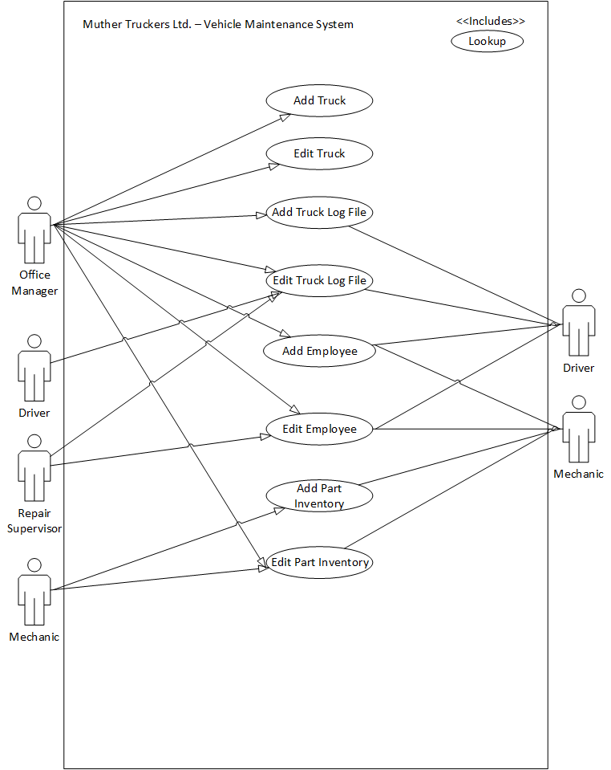

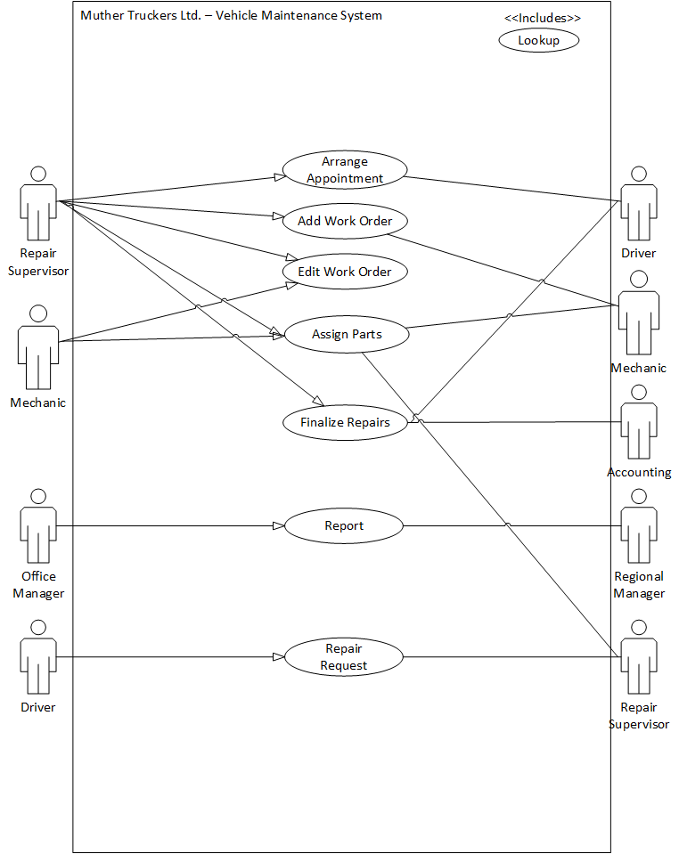

# Class Diagram

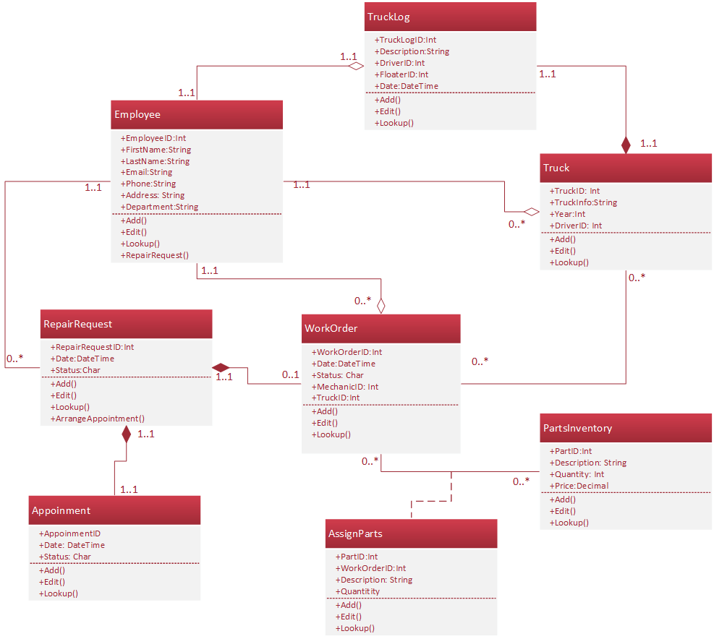

# Use Case Narratives

|  |  |  |
| --- | --- | --- |
| **Use Case Name:** | Lookup | |
| **Description:** | User requires information | |
| **Actor(s):** | Repair Supervisor, Mechanic, Driver, Office Manager | |
| **Related Use Cases** | Add Truck, Edit Truck, Add Truck Log File, Edit Truck Log File, Add Employee, Edit Employee, Add Part Inventory, Edit Part Inventory, Arrange Appointment, Add Work Order, Edit Work Order, Finalize Repairs, Report, Repair Request | |
| **Stakeholders** | Repair Supervisor, Mechanic, Driver, Office Manager | |
| **Preconditions:** | Information needs to be looked up | |
| **Trigger:** | Information has been looked up | |
| **Normal flow of events:** |  |  |
| 1. User requests information | 2. System returns requested information and a confirmation of a successful lookup |
| **Alternate flow of events:** | N/A |  |
| **Post-conditions:** | Requested information is retrieved. | |
| **Outstanding Issues:** | N/A | |

|  |  |  |
| --- | --- | --- |
| **Use Case Name:** | Add Truck | |
| **Description:** | A new truck is added to the vehicle inventory so that it is available for future reservations. | |
| **Actor(s):** | Office Manager | |
| **Related Use Cases:** | Look up, Edit Truck, Add Truck Log File, Edit Truck Log File | |
| **Preconditions:** | The truck must be a unique entry to the system. | |
| **Stakeholders:** | N/A | |
| **Trigger:** | A new truck is acquired by the company and must be added to the truck inventory. | |
| **Normal flow of events:** | **Actor action** | **System Response** |
| 1. The Office Manager enters vehicle information for a new and unique entry. | 2. The system returns confirmation of the truck being added |
| **Alternate flow of events:** | N/A | |
| **Post-conditions:** | A new truck is added to the systems inventory. | |
| **Outstanding Issues:** | N/A | |

|  |  |  |
| --- | --- | --- |
| **Use Case Name:** | Edit Truck | |
| **Description:** | An existing truck with the system has its information updated. | |
| **Actor(s):** | Office Manager | |
| **Related Use Cases:** | Look up, Add Truck, Add Truck Log File, Edit Truck Log File, | |
| **Preconditions:** | The truck being edited must already exists within the system | |
| **Stakeholders:** | N/A | |
| **Trigger:** | An existing truck needs its information updated or changed. | |
| **Normal flow of events:** | **Actor action** | **System Response** |
| 1. The Office Manager looks up an existing truck within the system    2. The Office Manager selects a truck and edits its information. | 3. The system returns confirmation of the truck saved and edited truck data |
| **Alternate flow of events:** | N/A | |
| **Post-conditions:** | The existing truck information has been edited. | |
| **Assumptions:** | N/A | |

|  |  |  |
| --- | --- | --- |
| **Use Case Name:** | Add Employee | |
| **Description:** | A new employee has been added. The actor will input employee information and saves it. | |
| **Actor(s):** | Office Manager | |
| **Related Use Cases** | Lookup, Edit Employee | |
| **Stakeholders** | Mechanic, Driver | |
| **Preconditions:** | Employee must not exist on the system. | |
| **Trigger:** | A new employee is added. | |
| **Normal flow of events:** |  |  |
| 1. The user looks up employee.  2. The actor enters the employee information into the file. | 3. System confirms that the new employee was created successfully. |
| **Alternate flow of events:** | N/A | N/A |
| **Post-conditions:** | Repair supervisor can add a job/work order to the employee and will reflect on their file | |
| **Outstanding Issues:** | N/A | |

|  |  |  |
| --- | --- | --- |
| **Use Case Name:** | Edit Employee | |
| **Description:** | The actor will lookup employees’ record, edit some fields and saves it. | |
| **Actor(s):** | Repair Supervisor /Office Manager | |
| **Related Use Cases** | Lookup, Add Work Order, Edit Work Order | |
| **Stakeholders** | Driver, Mechanic | |
| **Preconditions:** | Employees’ record must exist. | |
| **Trigger:** | Employee is updated | |
| **Normal flow of events:** |  |  |
| 1. The actor looks up EmployeeID and/or any Employee information.  2. The actor will edit necessary fields. | 3. The system returns confirmation and updates the record. |
| **Alternate flow of events:** | N/A | N/A |
| **Post-conditions:** | Employees’ information will be updated on the system and will reflect on their file | |
| **Outstanding Issues:** | N/A | |

|  |  |  |
| --- | --- | --- |
| **Use Case Name:** | Add Part Inventory | |
| **Description:** | A new part is added to the parts inventory so that it is available for future use. | |
| **Actor(s):** | Mechanic | |
| **Related Use Cases** | Lookup, Edit Part Inventory, Assigned Parts, Add Work Order, Edit Work Order | |
| **Stakeholders** | Mechanic | |
| **Preconditions:** | The part must be a unique entry to the system. | |
| **Trigger:** | A new part is acquired by the company and must be added to the parts inventory. | |
| **Normal flow of events:** |  |  |
| 1. The user enters part information for a new, unique, entry. | 2. The system returns confirmation of the part being added. |
| **Alternate flow of events:** | N/A | N/A |
| **Post-conditions:** | The new part is added to the system. | |
| **Outstanding Issues:** | N/A | |

|  |  |  |
| --- | --- | --- |
| **Use Case Name:** | Edit Part Inventory | |
| **Description:** | An existing part in inventory is updated | |
| **Actor(s):** | Mechanic | |
| **Related Use Cases** | Lookup, Add Part Inventory, Assigned Parts, Add Work Order, Edit Work Order | |
| **Stakeholders** | Mechanic | |
| **Preconditions:** | The part being edited must exist within the system | |
| **Trigger:** | An existing part is changed, and the system entry must reflect said changes. | |
| **Normal flow of events:** |  |  |
| 1. The actor looks up an existing part within the system.  2. The actor selects an entry and makes the necessary edits to the part data. | 3. The system returns confirmation of the part data being edited. |
| **Alternate flow of events:** | N/A |  |
| **Post-conditions:** | The existing part has its information edited | |
| **Outstanding Issues:** | N/A | |

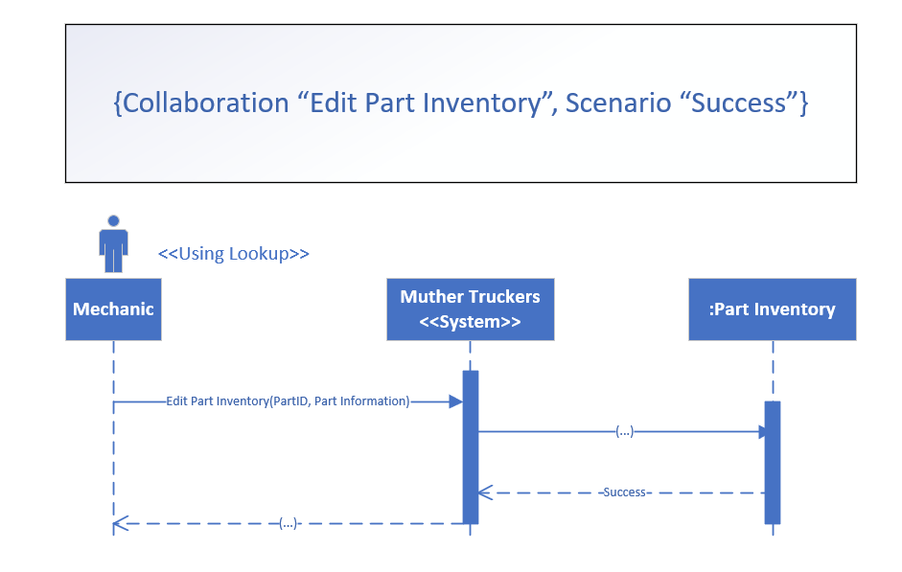

|  |  |  |
| --- | --- | --- |
| **Use Case Name:** | Add Truck Log File | |
| **Description:** | A new truck log file is created. | |
| **Actor(s):** | Office Manager | |
| **Related Use Cases** | Lookup, Add Truck, Edit Truck, Add Driver, Edit Driver | |
| **Stakeholders** | Driver | |
| **Preconditions:** | Truck must exist | |
| **Trigger:** | New truck is added. | |
| **Normal flow of events:** |  |  |
| 1.User looks up the truck log information  2.The actor enters the driver’s information into the truck file.  4.The actor clicks print. | 3.System confirms that the Truck Log File was created successfully.      5.Paper copy of truck log file is printed. |
| **Alternate flow of events:** | N/A | N/A |
| **Post-conditions:** | Truck log is created, and a paper copy is printed for the driver. | |
| **Outstanding Issues:** | N/A | |

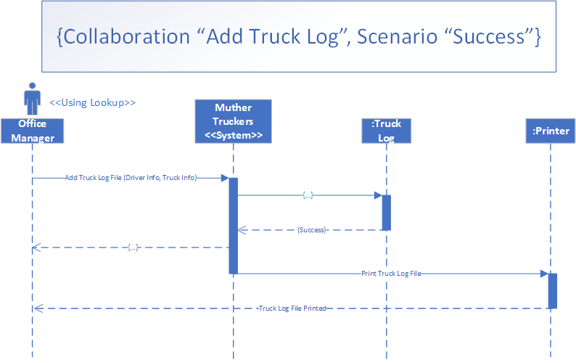

|  |  |  |
| --- | --- | --- |
| **Use Case Name:** | Edit Truck Log File | |
| **Description:** | Information on the truck log needs to be updated. | |
| **Actor(s):** | Repair Supervisor, Office Manager | |
| **Related Use Cases** | Lookup, Add Truck, Edit Truck, Repair Request, Add Work Order, Edit Work Order | |
| **Stakeholders** | Driver, Regional Manager | |
| **Preconditions:** | Truck Log File must exist. | |
| **Trigger:** | New driver is assigned to the truck.  Repairs were made to the truck and/or truck log needs to be printed. | |
| **Normal flow of events:** |  |  |
| 1. Actor looks up truck log file  2. The actor updates the truck log file to reflect changes that were made.  5. Actor selects print | 3. The system confirms the changes were saved.  4. The system asks the user if they would like to print out the truck log.  6. System prints the file. |
| **Alternate flow of events:** | N/A | N/A |
| **Post-conditions:** | Truck log is updated, and a paper copy is printed for the driver. | |
| **Outstanding Issues:** | N/A | |

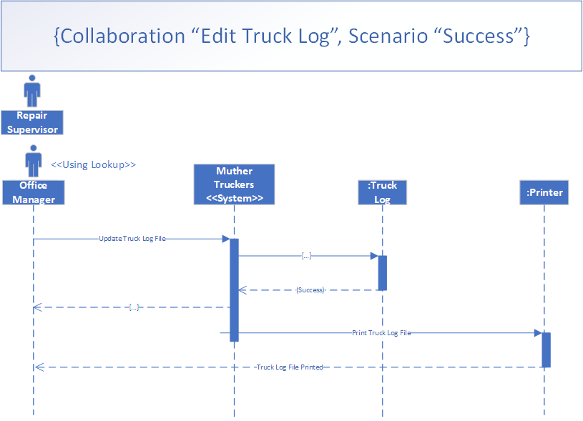

|  |  |  |
| --- | --- | --- |
| **Use Case Name:** | Arrange Appointment | |
| **Description:** | The repair supervisor arranges an appointment date and time mutually acceptable to the driver and the shop. | |
| **Actor(s):** | Repair Supervisor | |
| **Related Use Cases** | Add Work Order, Edit Work Order, Repair Request Process, Look up | |
| **Stakeholders** | Driver | |
| **Preconditions:** | Repair request process must exist.  Driver must exist.  Truck must exist. | |
| **Trigger:** | Repair supervisor needs to schedule an appointment to make repairs on the truck. | |
| **Normal flow of events:** |  |  |
| 1. Supervisor lookups shop availability  2. Supervisor confirms driver availability and selects an available date | 3. System confirms appointment has been arranged. |
| **Alternate flow of events:** | N/A | N/A |
| **Post-conditions:** | Appointment is made. | |
| **Outstanding Issues:** | N/A | |

|  |  |  |
| --- | --- | --- |
| **Use Case Name:** | Add Work Order | |
| **Description:** | Driver brings the malfunction truck to the repair shop under an appointment to meet with a mechanic. | |
| **Actor(s):** | Repair Supervisor | |
| **Related Use Cases** | Lookup, Arrange Appointment, Add Part, Edit Part | |
| **Stakeholders** | Driver, Mechanic | |
| **Preconditions:** | Work order cannot exist  Truck log must be presented  Repair Request must be presented  Additional information is obtained from the driver | |
| **Trigger:** | Driver brings the truck to the repair shop | |
| **Normal flow of events:** |  |  |
| 1 User lookups the system for repair request  2 User fills in essential information in all required fields of the work order. | 3 System returns successful message of newly created work order. |
| **Alternate flow of events:** | N/A | N/A |
| **Post-conditions:** | A new work order has been created. | |
| **Outstanding Issues:** | N/A | |

|  |  |  |
| --- | --- | --- |
| **Use Case Name:** | Edit Work Order | |
| **Description:** | When the repair is completed, the mechanic notifies the repair supervisor to update the cost in work order. | |
| **Actor(s):** | Repair Supervisor | |
| **Related Use Cases** | Lookup, Arrange Appointment, Add Part, Edit Part | |
| **Stakeholders** | Driver, Mechanic | |
| **Preconditions:** | A work order must exist.  A repair job is completed. | |
| **Trigger:** | Mechanic finishes the repair for a truck | |
| **Normal flow of events:** |  |  |
| 1. User lookups the work order in database.  2. User updates the labor, part, and material cost information.  4. User updates the status of work order. | 3. System returns a successful message on the update.  5. System returns a successful message on the update. |
| **Alternate flow of events:** | N/A | N/A |
| **Post-conditions:** | Work order is updated. | |
| **Outstanding Issues:** | N/A | |

|  |  |  |
| --- | --- | --- |
| **Use Case Name:** | Assign Parts | |
| **Description:** | Add parts to work order for truck repairs | |
| **Actor(s):** | Mechanic, Repair Supervisor | |
| **Related Use Cases** | Lookup, Add Part, Edit Part, Add Work Order, Edit Work Order | |
| **Stakeholders** | Mechanic, Repair Supervisor | |
| **Preconditions:** | The part inventory item must exist  The Work order must exist | |
| **Trigger:** | A part needs to be added to the work order | |
| **Normal flow of events:** |  |  |
| 1. The clerk looks up an existing part within the system  2. The clerk adds the necessary part(s) to the work order | 3. The system returns confirmation of the part data being added |
| **Alternate flow of events:** | N/A | N/A |
| **Post-conditions:** | The part is added to the work order | |
| **Outstanding Issues:** | N/A | |

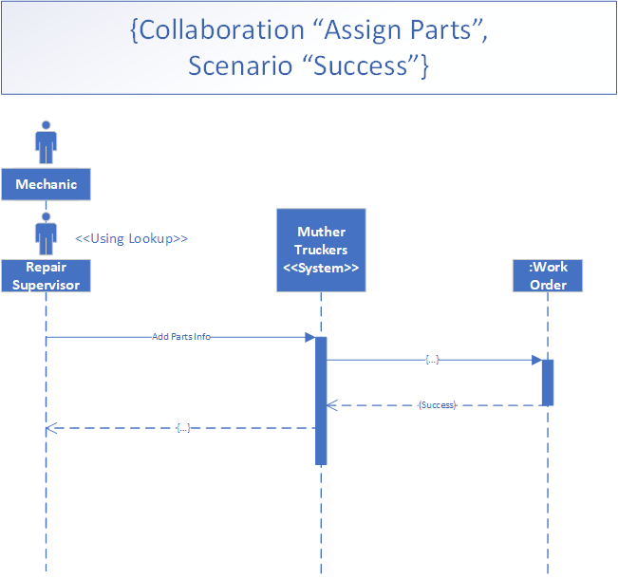

|  |  |  |
| --- | --- | --- |
| **Use Case Name:** | Finalize Repairs | |
| **Description:** | Final information updates upon completion of the truck repairs | |
| **Actor(s):** | Repair Supervisor | |
| **Related Use Cases** | Lookup, Add Part Inventory, Edit Part Inventory, Add Work Order, Edit Work Order, Edit Truck Log, Edit Employee | |
| **Stakeholders** | Driver, Accounting | |
| **Preconditions:** | There must be an open work order that is reaching completion | |
| **Trigger:** | The repair for a truck is completed | |
| **Normal flow of events:** |  |  |
| 1. Repair Supervisor enters labor cost, parts, and materials cost into the work order  3. Updates the truck log file and prints a physical copy for the driver  6. Repair Supervisor closes the work order by changing its status to “completed” | 2. System returns confirmation of the work order data being edited.  4. System returns confirmation of the truck log file being edited  5. System confirms print request for truck log  7. System returns confirmation of the work order status being changed. |
| **Alternate flow of events:** | N/A | N/A |
| **Post-conditions:** | The work order is set as completed; the repairs are complete. | |
| **Outstanding Issues:** | N/A | |

|  |  |  |
| --- | --- | --- |
| **Use Case Name:** | Report | |
| **Description:** | Office manager accesses the truck log file, parts inventory file and the employee file to prepare the necessary reports to send to the Regional Manager in Toronto. | |
| **Actor(s):** | Office Manager | |
| **Related Use Cases** | Look up, Add Truck Log File, Edit Truck Log File, Add Part, Edit Part, Add Work Order, Edit Work Order, Add Employee, Edit Employee, | |
| **Stakeholders** | Regional Manager | |
| **Preconditions:** | Work Order must exist,  Truck Log File exists,  Parts file must exist | |
| **Trigger:** | Each month the office manager needs to send a report for the regional manager | |
| **Normal flow of events:** |  |  |
| 1. The user sends report information about truck log, part, and employee | 2. System returns a successful message |
| **Alternate flow of events:** | N/A | N/A |
| **Post-conditions:** | Report is created and sent to the regional manager. | |
| **Outstanding Issues:** | N/A | |

|  |  |  |
| --- | --- | --- |
| **Use Case Name:** | Repair Request | |
| **Description:** | Driver needs repairs done to their truck. They submit a repair request form to the repair shop supervisor. | |
| **Actor(s):** | Driver | |
| **Related Use Cases** | Add Work Order, Edit Work Order, Arrange Appointment, Look up | |
| **Stakeholders** | Repair Supervisor | |
| **Preconditions:** | Vehicle and assigned driver must exist. | |
| **Trigger:** | Truck needs repairs | |
| **Normal flow of events:** |  |  |
| 1. Driver completes repair request form and submits it to the repair shop supervisor. | 2. System confirms the form has been sent. |
| **Alternate flow of events:** | N/A | N/A |
| **Post-conditions:** | Repair request form is sent to the repair supervisor. | |
| **Outstanding Issues:** | N/A | |

# Summary

In this report, we designed the physical models and documents based on the existing Muther Truckers Ltd. Vehicle Maintenance System. Team Placeholder visualized the system by creating a Use Case Diagram and breaking up the individual processes into multiple use case narratives. Team Placeholder has also further detailed these processes via an Event Table and a Class Diagram.